**User guide for space-time-diagram_gmns**

Yongxiang Zhanga,*, Xuesong Zhoub

aSchool of Transportation and Logistics, Southwest Jiaotong University, Chengdu 610031, China

bSchool of Sustainable Engineering and the Built Environment, Arizona State University, Tempe, AZ 85281, USA

*Contact e-mail: [bk20100249@my.swjtu.edu.cn](mailto:bk20100249@my.swjtu.edu.cn)

The program “space-time diagram.py” written in Python 3.7 first read the data from the files **node.csv, road_link.csv and agent.csv** of NeXTA-GMNS (the Github repository of NeXTA-GMNS is available at <https://github.com/xzhou99/NeXTA-GMNS>), and the space-time trajectories of the vehicles on a path (i.e., a set of sequentially connected road links) are displayed in a figure using the Python matplotlib library.

The fields of data in the three .csv files that are necessary are listed as follows:

**1. node.csv**

|  |  |  |
| --- | --- | --- |
| **Field Name** | **Description** | **Sample Value** |
| name | Optional for visualization only | Main street @ Highland Dr. |
| node_id | Node identification number | 1001 |
| x_coord | Longitude or horizontal coordinate in any arbitrary geographic coordinate system. | 100 |
| y_coord | Latitude or vertical coordinate horizontal coordinate in any arbitrary geographic coordinate system | 200 |

**2. road_link.csv**

|  |  |  |
| --- | --- | --- |
| **Field Name** | **Description** | **Sample Values** |
| name | Optional for visualization purposes | Main Street |
| road_link_id | Link identification number of the road | 101 |
| from_node_id | Upstream node number of the link, must already defined in input_node.csv | 2 |
| to_node_id | Downstream node number of the link, must already defined in input_node.csv | 3 |
| length | The length of the link (between end nodes), measured in units of mile, km or other units. | 1.0 |
| display_sequence | The order of the road link in the path with a given direction. Note that the value of “display_sequence” starts from 0, and the link is not included if the value of “display_sequence” equals to -1 | 1 |

**3. agent.csv**

|  |  |  |
| --- | --- | --- |
| **Field Name** | **Description** | **Sample Value** |
| agent_id | Node identification number | 1 |
| o_node_id | Origin node id of the agent | 1 |
| d_node_id | Destination node id of the agent | 20 |
| agent_type | Optional text label for visualization purpose | high-speed |
| node_sequence | The number of nodes through which agents pass in turn | 0;1;2;3;4; |
| time_sequence | The time stamps on the set of nodes through which agents pass in turn, and each time stamp is denoted by the format “HHMM:SS” | 0700;0701;0702;0703;0704; |

Fig. 1 shows an illustrative example for the display of space-time diagram, and there are 6 nodes and 6 road links in the artificial road network. In Fig. 1, the node numbers and names are depicted beside the nodes. Moreover, the numbers in a bracket beside a road link show the link number and link travel time. For instance, (0, 1) denote the link 0 with the travel time of 1 min. Moreover, there are two paths in Fig. 1, the set of noes {1, 2, 3, 101, 202} for path 1 and {1, 2, 3, 320, 400} for path 2.

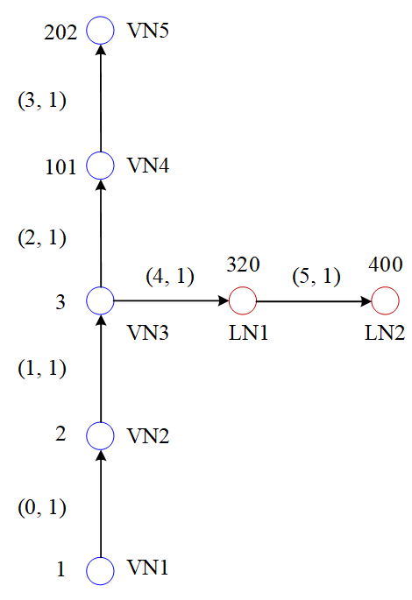

Fig. 1. Layout of the artificial road network

Figs. 2-4 shows the values of the related data for the **node.csv, road_link.csv and agent.csv** files. There are 2 agents traveling on path 1 from node 1 to node 4 and 2 agents traveling on path 2 from node 0 to node 6. Fig. 5-6 shows the space-time diagram of the four agents on path 1 and path 2, respectively.

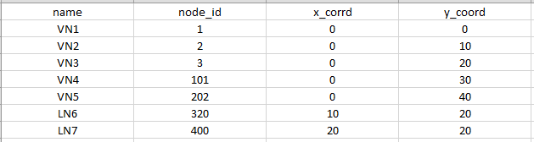

Fig. 2. Input data for the node.csv file

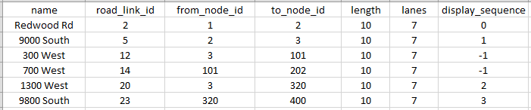

Fig. 3. Input data for the road_link.csv file

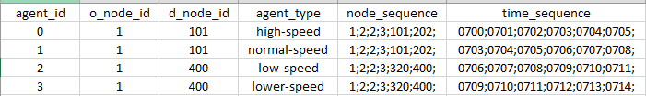

Fig. 4. Input data for the agent.csv file

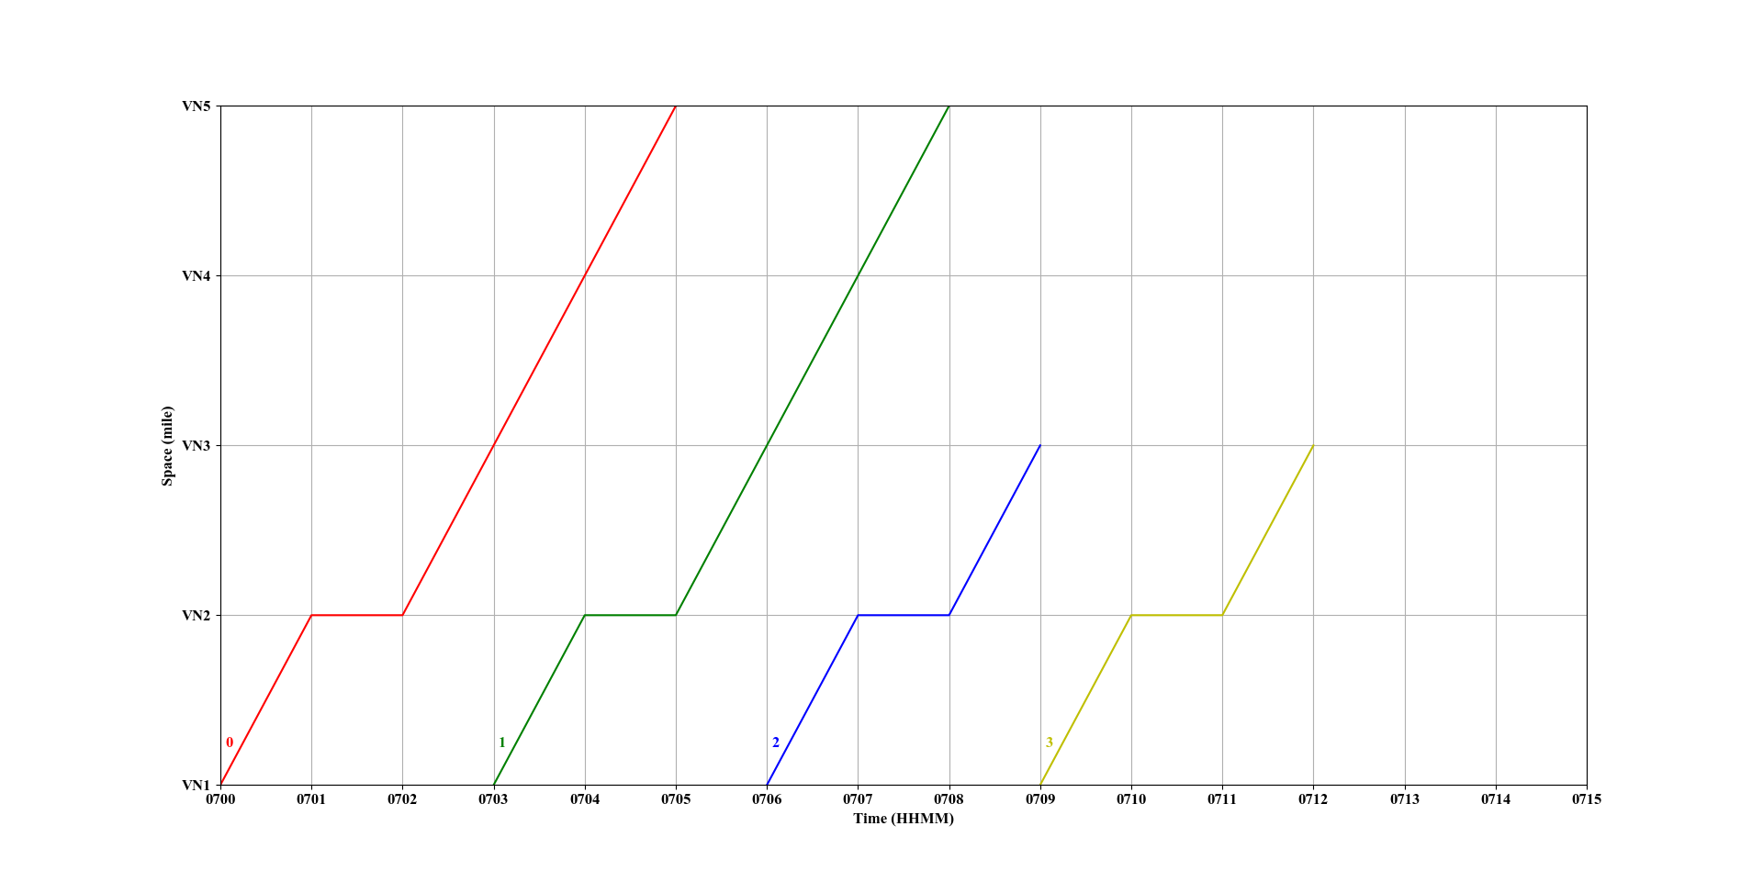

Fig. 5. Space-time diagram of the 4 agents on path 1

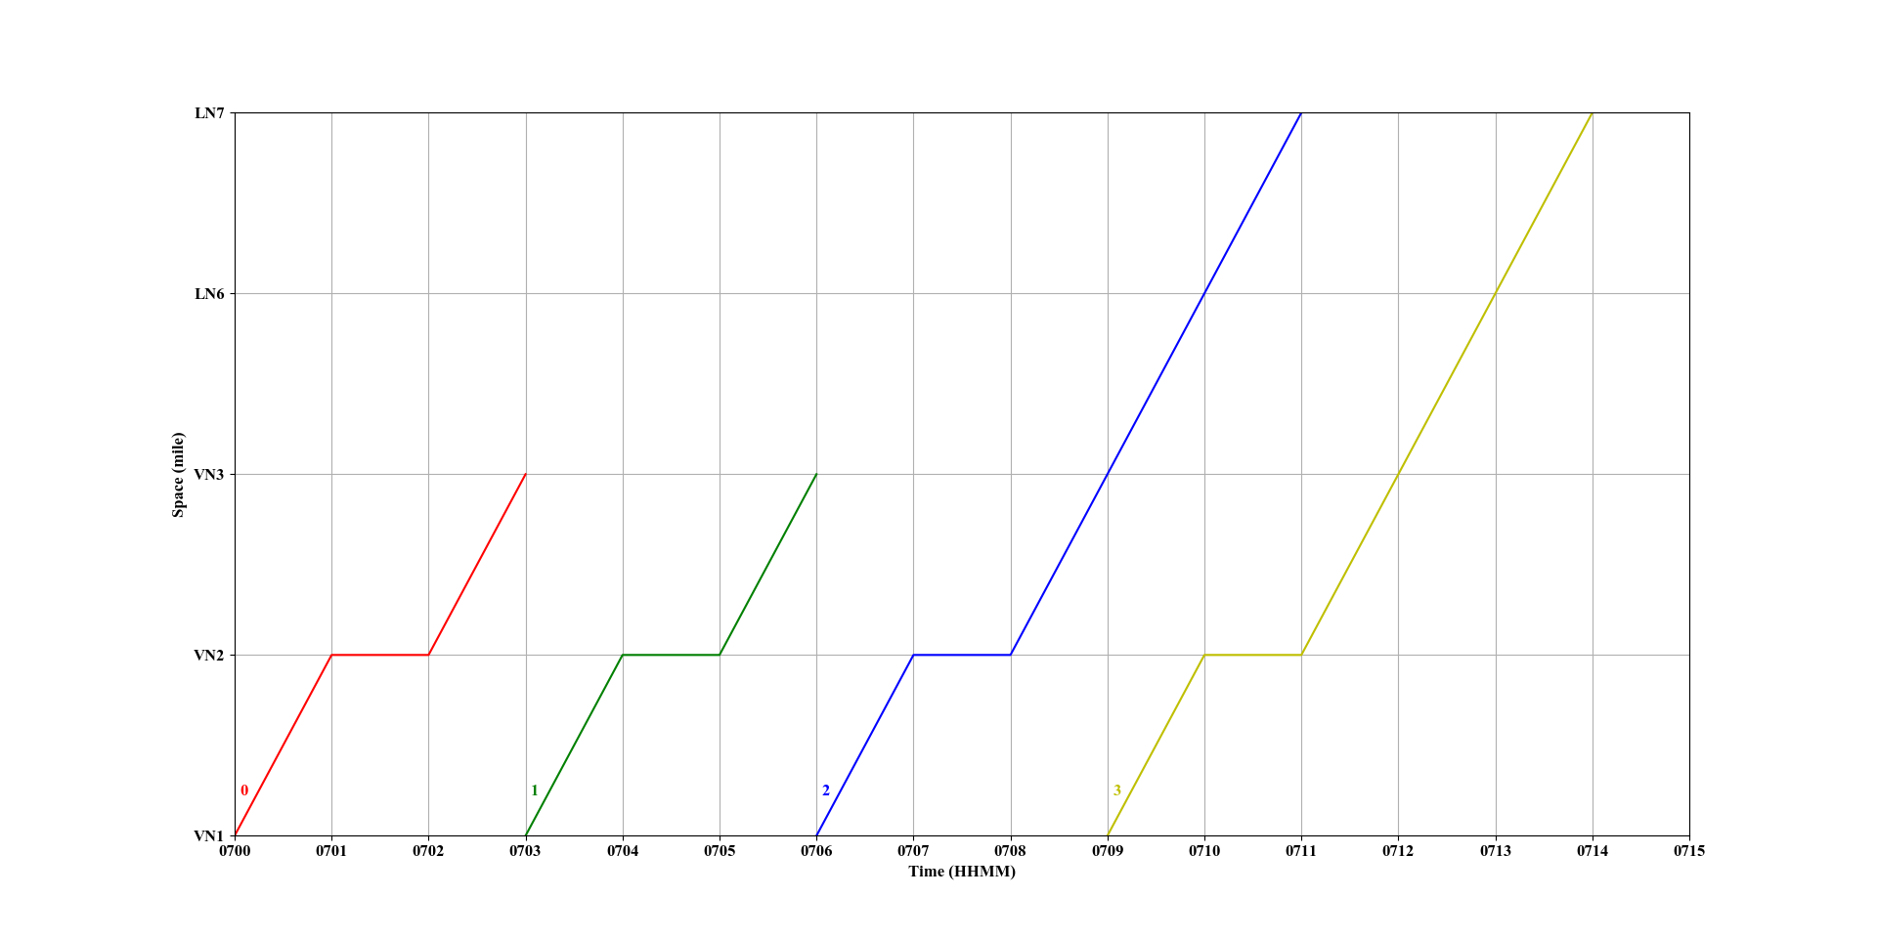

Fig. 6. Space-time diagram of the 4 agents on path 2